**Smart Car-Washing System**

This embedded project is based on finite state machines (FSM) tasks that are coordinated by a cooperative scheduler that can manage two kinds of tasks, synchronous and asynchronous tasks. Tasks don’t need to share variables or to be managed because each one knows its context and can interact with a tasks factory and the scheduler to stop, resume, add and remove tasks currently active on the scheduler. Asynchronous tasks are executed only one time, can be executed in any moment and in my case are the only tasks present in the scheduler when active, so they are quicky executed and then deleted forever.

**Tasks**

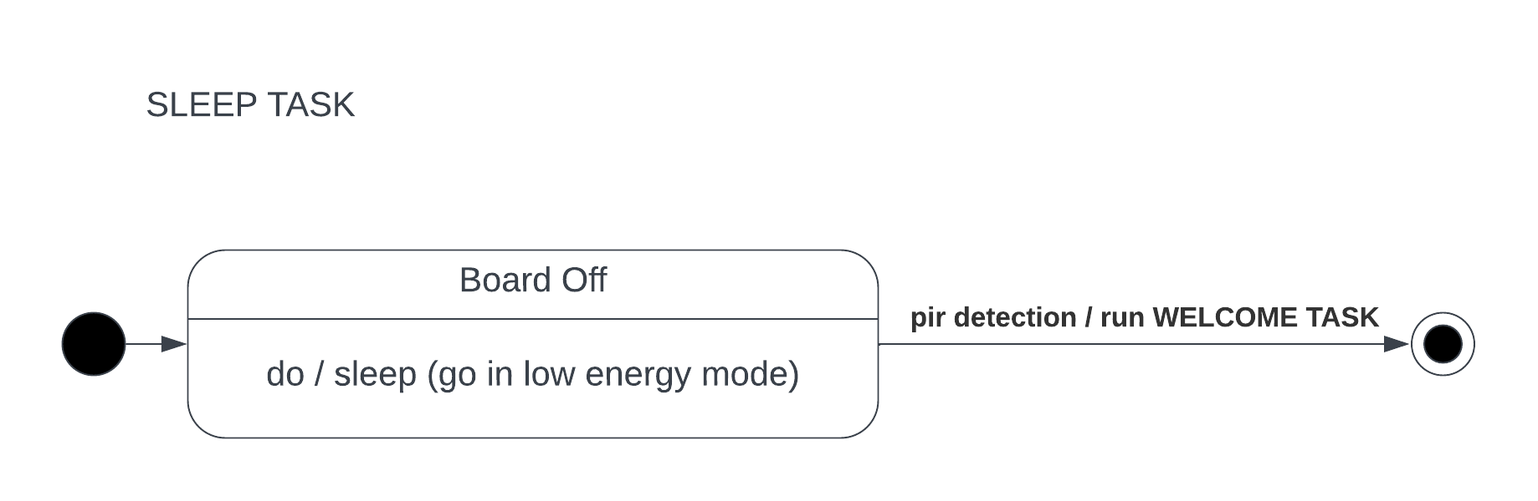The first task is the Sleep Task that is the only asynchronous task in my system and has the aim to make Arduino go in low energy mode until the pir detects a car that wants to enter in the washing area.

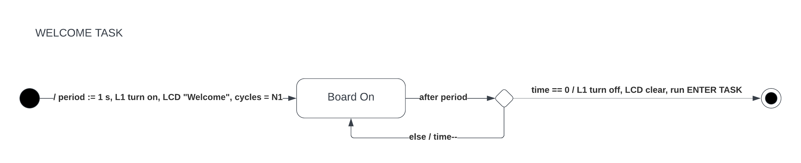The second task is the Welcome Task that gives the Welcome to the customer car and turns on and off light L1.

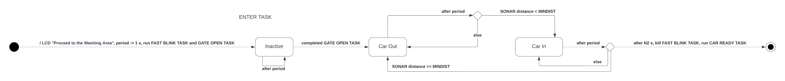The third task is the Enter Task that manages the gate opening process, the light L2 fast blinking and the car entrance through the sonar sensor.

The fourth task is the Open Gate Tasks that progressively opens the gate.

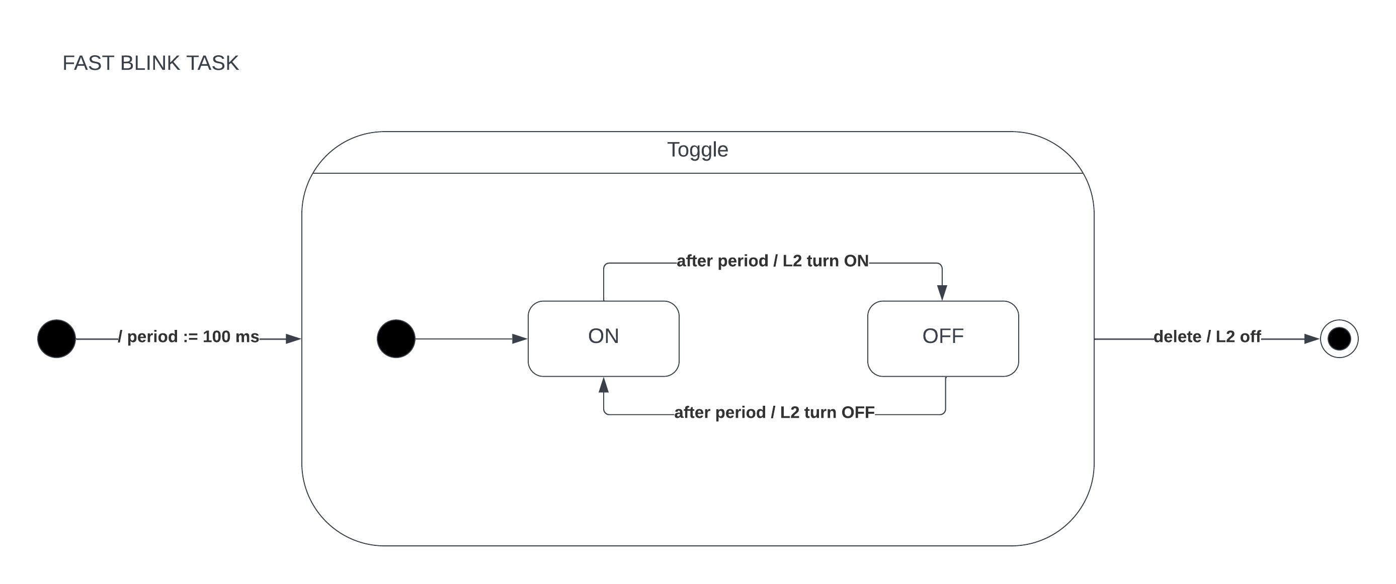The fifth task is the Fast Blink Task that toggles light L2 very quickly.

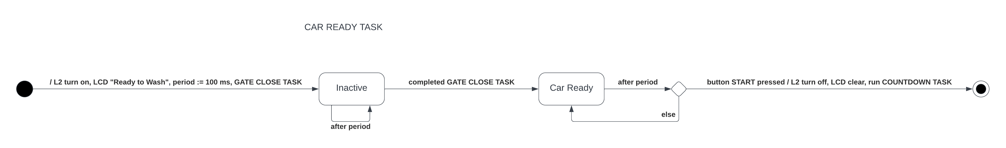The sixth task is the Car Ready Task that waits until the customer starts the washing by clicking a button.

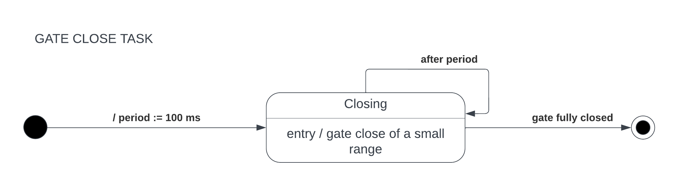The seventh task is the Gate Close Task that closes progressively the gate.

The eighth task is the Countdown Task that shows a countdown on the LCD display during the simulated washing process.

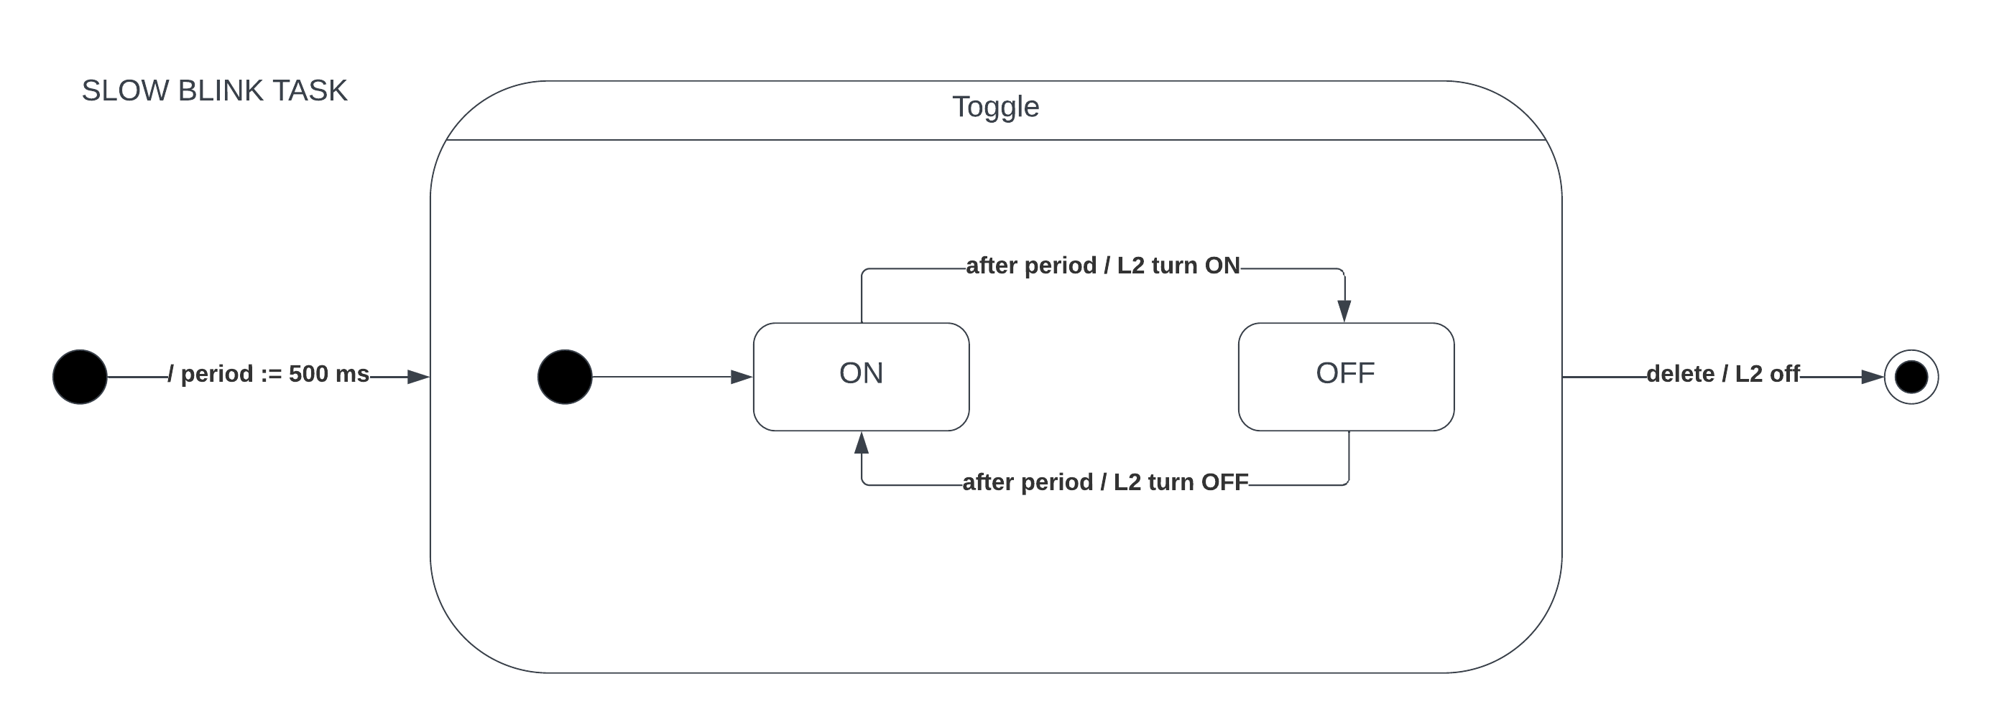The ninth task is the Slow Blink Task that toggles light L2 slowly.

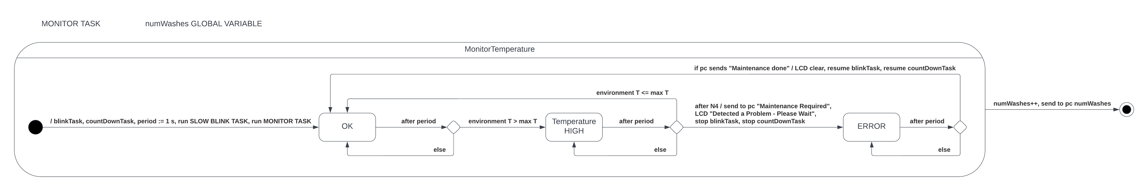The tenth task is the Monitor Tasks that monitors environment temperature and interacts with the pc via serial line for error communication and to show washes done and current temperature into the washing area.

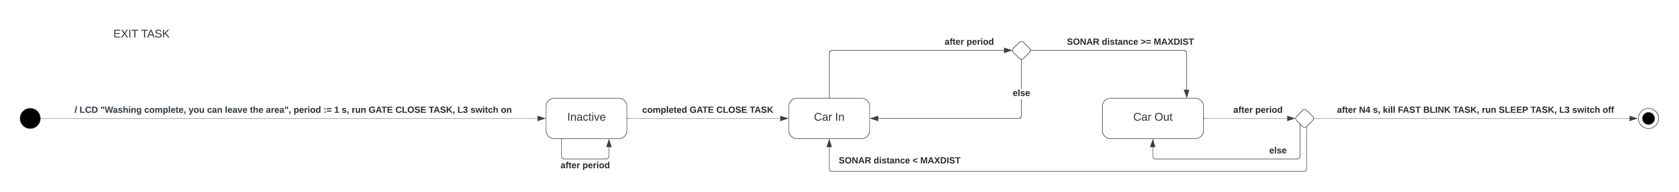The eleventh task is the Exit Task that turns on light L3, waits until the car is out of the washing area and after turning off L3, restarts the process from the Sleep Task.

**Schema**